**ANSWER ALL QUESTIONS**

**40 MARKS**

**Duration: 2 Hours**

Netflix, Hulu, Disney+, Amazon Prime Video – streaming services have taken over our computer monitors and mobile screens. And, according to a new report, your TV screen is next.

People are increasingly using their televisions to consume content from online streaming services, according to Nielsen’s new special “streaming wars” edition of its Total Audience Report. Consumers are currently spending 19% of their time in front of a TV screen streaming.

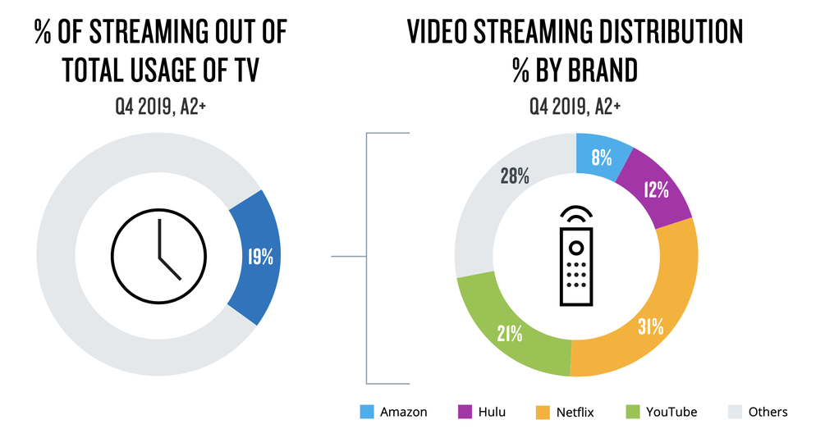

**IMAGE: NIELSEN**

Out of all the streaming services battling it out for your television, Netflix is currently dominating the heap. The subscription-based service makes up 31 percent of the content U.S. consumers stream on their TV set. Interestingly, a free streaming platform – YouTube – comes in second at 21 percent. Hulu and Amazon Prime Video round out the top four with all other streaming services combined accounting for 28 percent [1].

Uber, Grab, and other similar applications already disrupted the traditional taxi business, like wise WhatsApp kind of applications already disrupted telecom industry. The above discussion on “streaming services” already a potential negative signal for TV channel service providers / broadcasting services.

In light of the above,

Question 1: Critically analyse the streaming service firms with established TV broadcasting companies on the common traps or pitfalls in trying to get familiar with emerging technologies.

(20 Marks)

Question 2: Examine the possible solutions for TV broadcasting business to overcome the above traps or pitfalls. (20 marks)

Reference:[1]. <https://mashable.com/article/streaming-services-television-netflix-nielsen-report/>